Pdf-Mithra
Your friendly companion for PDF highlights.
Free · Mac & Windows · Open Source

Story — Website & LinkedIn Post
Copy and edit as needed before posting.

Hi everyone,

After years in academia, I've come to realise there are certain things we all just quietly wish worked better — and nobody ever gets around to fixing them.

One of those things, for me, was PDF annotations. You spend hours reading a paper, highlighting key arguments, leaving comments in the margins, colour-coding everything. And then when it's time to actually write — the lit review, the study notes, the summary — all of that work is just sitting trapped inside the file. There's no way to get it out without copy-pasting line by line.

That's one of the first things I built when I started learning Claude Code. I described the problem, worked through it with the tool, and a few sessions later had something that actually solved it.

Here is the fruit of that labour.
Pdf-Mithra is a free desktop app that pulls every highlight, underline, comment, and sticky note out of your PDFs and turns them into clean, structured notes — automatically grouped by the section of the document they came from.

- Export as Markdown, CSV, Obsidian callouts, or an HTML report with search and filters.
- Drop multiple PDFs at once for a combined export — useful for literature reviews.
- Label what your highlight colours mean, and your exports carry those labels.

Free for anyone to use. Always.
github.com/drkbhere/pdf-mithra

What it looks like

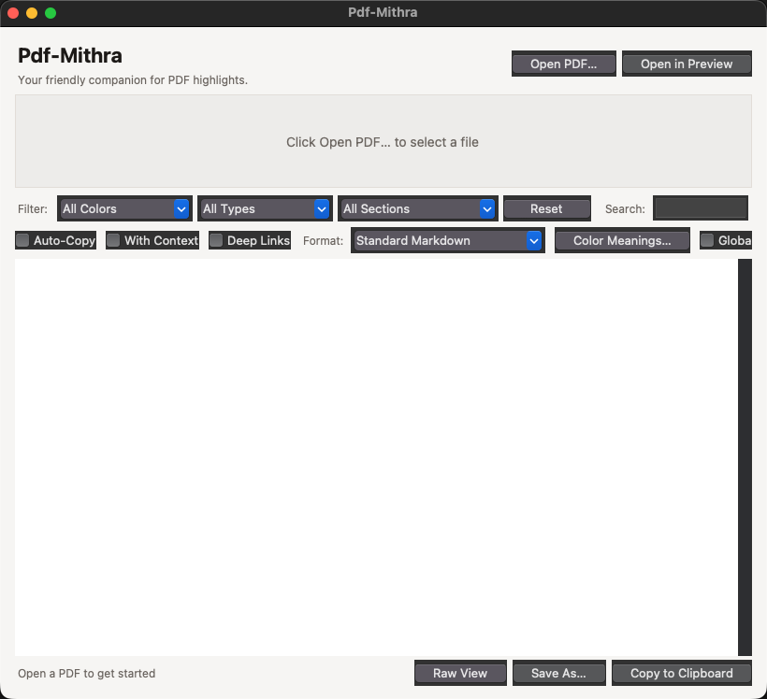
Pdf-Mithra — ready to receive a PDF

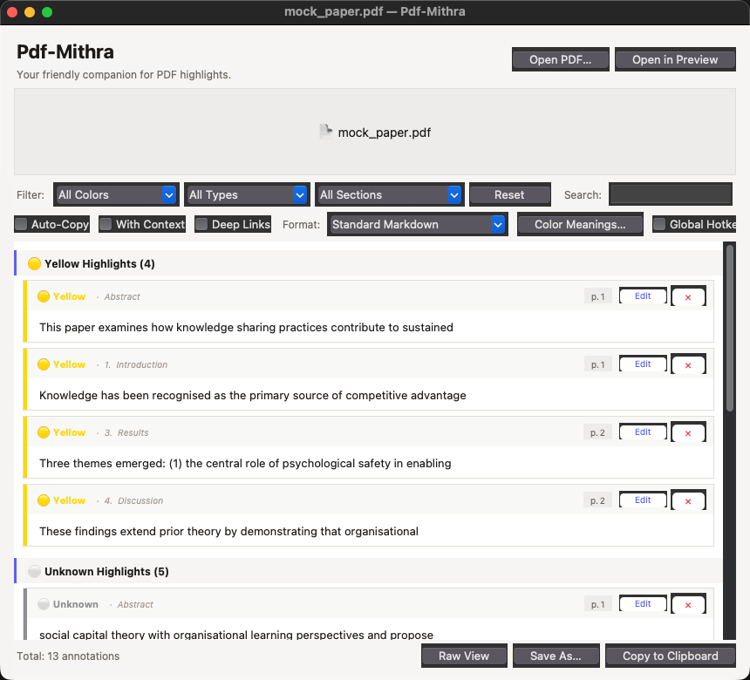
Pdf-Mithra — annotations extracted and grouped by section (Abstract, Introduction, Results, Discussion)

Features

Automatic section detection
Pdf-Mithra reads the structure of your PDF and groups annotations under the correct section heading automatically — Introduction, Methods, Results, Discussion, and so on. No manual tagging needed. Works with academic papers, books, and reports.

Colour meaning system
Label what each highlight colour means to you. Three presets built in:
Preset | Yellow | Green | Blue | Red | Orange | Purple
Academic Reading | Key Argument | Evidence | Definition | Critique | Follow Up | Quote to Cite
Book Notes | Main Idea | Example | Vocabulary | Disagree | Action Item | Inspiring
Code Review | Question | Good Pattern | Reference | Bug / Issue | Refactor | Architecture

Or define your own labels — saved for every future PDF.

Six export formats
Format | Best for
Standard Markdown | General note-taking, works anywhere
Markdown + Metadata | Includes title, author, page count, word coverage
Obsidian Callout Blocks | Paste straight into your Obsidian vault
Markdown Table | Pipe-table format for any Markdown workflow
CSV | Open in Excel, Notion, Airtable — great for literature matrices
HTML Report | Self-contained file with search bar, colour filters, and print mode

Batch mode
Drop multiple PDFs at once. Pdf-Mithra processes all of them and exports a single combined file — ideal for literature reviews across dozens of papers.

Search and filter
Filter by colour, annotation type, or document section. Full-text search works across highlighted text, section names, and colour meanings.

Click to open at page (Mac)
Click any annotation card to jump directly to that page in Preview — useful when you want to re-read the context around a highlight.

Raw Markdown view
Toggle between the card view and a raw Markdown preview. Useful for checking exactly what will be copied or saved before exporting.

How to get started — Mac

Requirements
- macOS 12 (Monterey) or later
- Python 3.11 or later — download free from python.org/downloads

Important: Keep the Pdf-Mithra folder in your home directory — not in Desktop or Documents. macOS restricts app access to those folders.

First-time setup (Terminal, once only)
1. Download the Pdf-Mithra folder from github.com/drkbhere/pdf-mithra
2. Move it somewhere in your home folder (e.g. ~/Pdf-Mithra)
3. Open Terminal: press Cmd + Space, type Terminal, press Return
4. Type cd and a space, then drag the folder into Terminal. Press Return.
5. Run this command:
pip install -r requirements.txt
Takes about a minute. Never needed again.

Launching (every time)
Double-click Pdf-Mithra.app in the folder. No Terminal needed after setup.
If macOS shows a security warning the first time: right-click → Open → Open.

How to get started — Windows

Requirements
- Windows 10 or later
- Python 3.11 or later — download free from python.org/downloads

Important: During Python installation, tick "Add Python to PATH" — this is essential.

Setup and launch
1. Install Python from python.org/downloads — tick 'Add Python to PATH'
2. Download the Pdf-Mithra folder from github.com/drkbhere/pdf-mithra

3. Double-click Pdf-Mithra.bat in the folder.
On the first run it automatically installs all dependencies (~1 minute). Every run after that opens the app directly — no Terminal ever needed.

Tips
- Set up Color Meanings before you export. It takes 30 seconds and makes your output much more useful — especially for CSV and HTML.
- For a literature review: drop all your papers at once, switch to CSV, and open in Excel or Notion. You'll have a full annotation matrix in one go.
- The HTML Report is great for sharing — one file, opens in any browser, has search and colour filters built in, and prints cleanly.
- If you use Obsidian, the Obsidian Callout Blocks format pastes directly into a note.
- With Context mode extracts the surrounding sentences — useful when you want more than just the highlighted text itself.

Free to use. Always.
github.com/drkbhere/pdf-mithra

